Use-Case Realization Report (Analysis)
Send Cylinder to a Particular Step

Issue 1.0
Revision History
Date | Issue | Description | Author
29/Apr/2011 | 1.0 | Initial Document | Koh Ming Jin

Table of Contents
1. Brief Description 4
2. Flow of Events 4
2.1 Standard Flow 4
2.2 Exception 4
3. Interaction Diagrams 4
3.1 Collaboration Diagram for Sending Cylinder to a Particular Step 4
4. Participating Objects 4
4.1 Reroute Cylinder Page 4
4.2 Workflow Controller 5
4.3 Step Controller 5
4.4 Cylinder Controller 5
4.5 Error Controller 5
4.6 Step 5
4.7 Cylinder 5
4.8 Error 5
5. Class Diagrams 5
5.1 Domain Class Diagram: Sending Cylinder to a Step 5
6. Derived Requirements 6

Use-Case Realization Report
Send Cylinder to a Particular Step

Brief Description
This use case enables an operation manager to send a cylinder to a particular process step.

Flow of Events
The standard flow of events for this use case and any exceptions are described in the following subsections. See section 3.1 for an overview of the participating Actors and Domain Objects.

Standard Flow
The flow of events is described as follows:

- The use case starts when Operation Manager views a particular cylinder information and its next process step via a Reroute Cylinder Page (view Cylinder Info use case).
- The Operation Manager selects the Cylinder Forward Step option of a particular cylinder.
- The Operation Manager will scan the Cylinder barcode.
- Once the Operation Manager chooses the next process step, error type and click on update option and the updated information will be stored. Subsequently, the cylinder will be directed to the updated process step.
- The use case terminates.

Exception
- NIL

Interaction Diagrams

Collaboration Diagram for Sending Cylinder to a Particular Step
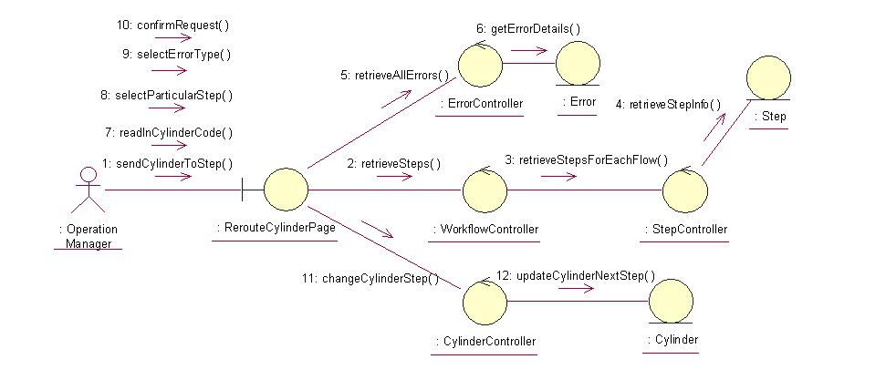

Participating Objects

Reroute Cylinder Page
This object renders the contents to allow authorized actors to perform the reroute of Cylinder request. The Director, Department Manager and Operation Manager actors use this object.

Workflow Controller
This object acts as the middleman between “RerouteCylinder” Page and the Step Controller object. It will translate interactions with the view into actions to be performed by the Step Controller and Step objects.

Step Controller
This object acts as the middleman between Workflow Controller and Step object. It will translate requests by Workflow Controller into actions to be performed by the Step object.

Cylinder Controller
This object acts as the middleman between “RerouteCylinder” Page and the Cylinder object. It will translate requests by “RerouteCylinder” Page into actions to be performed by the Cylinder object.

Error Controller
This object acts as the middleman between “RerouteCylinder” Page and the Error object. It will translate interactions with the view into actions to be performed by the Error object.

Step
This object stores the details concerning the step information of the COMS.

Cylinder
This object stores the details concerning the cylinder information of the COMS.

Error
This object stores the details concerning the error of the COMS.

Class Diagrams

Domain Class Diagram: Sending Cylinder to a Step
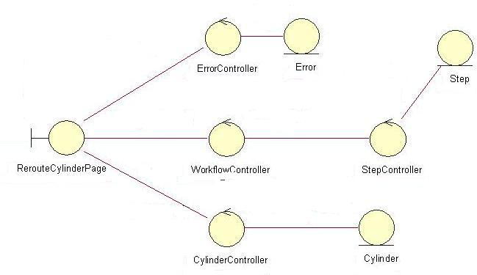

Derived Requirements
The Operation Manager PC keyboard and mouse will be used to enter process steps information details (if any) and view all the system responses.

